

OASFAA Site Selection Report

Date: 01/26/2026

Site Selection Chair – Name & Institution: Carlos Villarroel Portland Community College

Per OASFAA’s Policies and Procedures, 2.2.2.10 Site Selection:
The Site Selection Committee has the responsibility to research site for the annual conference across the state, visit the most likely candidates, and report back findings and recommendations to the Executive Council on a regular basis. Committee members will serve for at least a two-year term, with members rotating out during different years so that there is continuity to the membership and goals. If asked, the site selection committee could also research venues for Summer Drive In and other OASFAA trainings.

2025-2026 Goals:
- Spend more time actually looking at potential conference and training locations.
- Support OASFAA Conference/ Co-chairs.
- Look for ways to save costs for the annual conference and other events.

Recent Activities:
- Working closely with Co-chairs and Salishan to prepare for the conference.
- Purchased $708.56 of AV equipment to save an estimated cost of $1,902.88 annually for conference AV costs. This equipment along with projectors from TFF will supply the Gallery, Lincoln, Sitka, and Pine rooms. We should plan to have a dedicated Tech/AV person yearly to support set-up and take down.
- I will look to figure out how to set up the Longhouse for next year to stop from using Innovative Presentations completely to save an even larger amount yearly.

Budget: $1000 depends on travel for potential locations.

Upcoming Event: OASFAA Conference

Questions/Issues for Executive Council Feedback:
How do we generate more opportunities to keep OASFAA solvent??

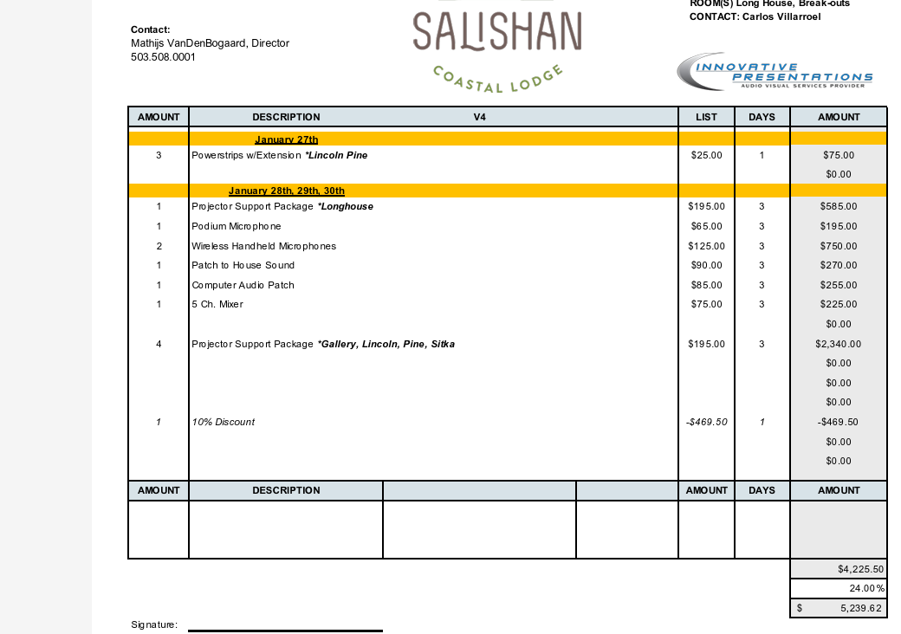
Purchased:
25 ft HDMI Cable x4
25 ft Power Cable x4
8ft Power Cable x4
Projector Screen x 4 (6ft-8ft)
Power Strip x11 (3 for Gallery)
Large 10ft Cord Cover x4
Medium 5ft Cord Cover x4
HDMI Adapters

