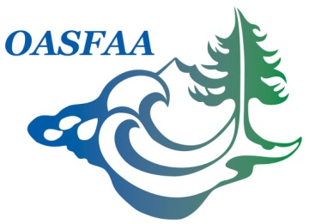

OASFAA Officer Report
Past-President
May 17, 2017

Committee Chair(s) – Name & Institution:
Jennifer Knight, Linfield College

Committee Member(s) – Name & Institution:
N/A

2017-2018 Goals:

Per the OASFAA Policy and Procedures Manual:

2.2.1.2 Past President
The (immediate) Past President primarily assists the President by providing information and insights concerning the previous year’s activities of the Executive Council. The Past President introduces the Policy and Procedures Manual to the newly elected Executive Council as part of the transition meeting agenda and updates the manual as directed by the Executive Council. The Past President may also serve as a regular voting member on committees. The Past President is responsible for coordinating the nominations and selection of OASFAA award recipients each year. They also present the awards to the recipients at the Annual Conference. The Past President serves from Annual Conference through Annual Conference.

- Assist the President by providing information and insights concerning the previous year’s activities of the Executive Council
- Introduce the Policy and Procedures Manual to the newly elected Executive Council as part of the transition meeting agenda and updates the manual as directed by the Executive Council
- Serve as a regular voting member on committees
- Coordinate the nominations and selection of OASFAA award recipients
- Present the awards to the recipients at the Annual Conference

Recent Activities:

- Ran OSFAA EC Transition Meeting on February 1, 2017. Introduced the Policy and Procedure Manual to the newly elected Executive Council and Committee Chairs.
- Ran Annual Business Meeting at Annual Conference and passed the Presidential Gavel to President on Feb 3, 2017
- Feb 3, 2017 - US Bank – meeting with President and Treasurer to remove my signatures and add President’s signature at US Bank in Lincoln City, OR
- Received Site Selection email for Sunriver location from past-past President
- Feb 7, 2017 - Notified President and Treasurer that US Bank only change over the Checking and not the Savings account signatures, so they will need to have that account changed over too
- Received vendor email contacts following up to OASFAA Conference
- Passed along a Keynote speaker idea email solicitation to the 3 Co-Chairs of Annual Conference, and cc’d President
- Participated in WASFAA Transition Executive Council Meeting in Reno, NV February 14-16, 2017
- Participate in WASFAA Executive Council Meeting in Seattle, WA April 10, 2017
- Attended WASFAA Annual Conference April 11-13, 2017 on behalf of OASFAA
  - Presented a break-out session as part of WASFAA President’s Group
- Participated in Webinar for Memberclicks
- Assisted President providing insights concerning previous year’s activities of the Executive Council for OASFAA and WASFAA

Budget:
N/A

