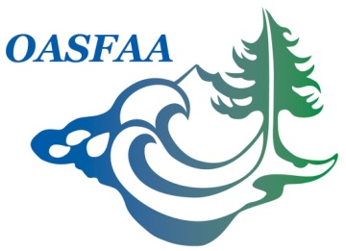

Community College VP Report
17 May 2017

VP for Community College Segment:
Karen Ash – Lane Community College

2017-2018 Goals:

- Implement monthly or quarterly conference call with community college members to allow the exchange of ideas and foster an environment for relevant financial aid information dialogue.
  - Topics could include:
    - State Budget
    - Federal updates
    - How are institutions implementing new regulations?
Recent Activities/Updates:

- Emailed 2-year public Listserv asking members to communicate any concerns or interests for the Executive Council Meeting
  - Asked members to respond by email their level of interest for monthly or quarterly conference call
- Submitted article for OASFAA Newsletter
  - Asked other community colleges to share their experience with the First year Experience for the Oregon Promise.

Budget:
None requested

