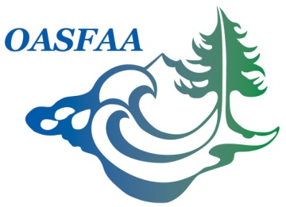

OASFAA Communications Committee Report
January 31, 2017

Committee Co-Chairs:
Rachael Kloke, Concordia University
Jessica Steinhebel, Oregon Community Foundation

2016-2017 Committee Members:
- Ashley Coleman, University of Oregon
- Amanda Hopkins, Concordia University
- Abril Hunt, ECMC
- G. Michael Johnson, Portland State University
- Jennifer Knight, Linfield College
- Mary McGlothlan, Concordia University
- Deborah O’Dea, Southern Oregon University
2016-2017 Goals:
Publish OASFAA newsletter in May and December.
Provide updates through social media to ensure OASFAA members stay informed.
Provide networking and fellowship opportunities for OASFAA members throughout the year.
Collaborate with other committees to provide timely information to members on social media.

Recent Activities:
November 13, 2016 submission of December 2016 newsletter.
Continued to submit information pertaining to OASFAA events to OASFAA Facebook page.
Sent notification email to committee members of open co-chair position within committee.

Action Items:
Continue to work with Training and Volunteer Chairs to ensure that training events and volunteer opportunities appear on social media and newsletter in a timely manner.
Recruit articles for May 2017 newsletter.
Re-evaluate networking (Happy Hour) events.
Discuss guidelines for social media usage with Executive Council to ensure that shared items engage members and stay within proposed guidelines.
Schedule quarterly meetings with committee members to discuss newsletter and social media.

Budget:
Unknown

